HOSPITAL EMERGENCY ROOM SQL QUERY
PATIENT KPI’S

-- 1) Total number of Patient

SELECT COUNT(*) AS total_patients
FROM hospital_emergency_room;

-- 2) Total number of Unique Patient

SELECT COUNT(DISTINCT patient_name) AS unique_patients
FROM hospital_emergency_room;

-- 3) Total number of Male and Female;

SELECT Patient_gender, COUNT(*) AS Total_patients
FROM hospital_emergency_room
GROUP BY Patient_gender;
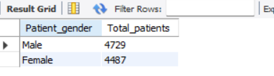
-- 4) Age group Distribution;

SELECT Patient_age_group, COUNT(*) AS Total_patients
FROM hospital_emergency_room
GROUP BY Patient_age_group
ORDER BY Total_patientS DESC;
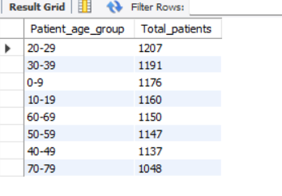
Admission Analysis
-- 1) Total no. of admitted and not admitted patient;

SELECT Patient_admission_status,
COUNT(*) AS total
FROM hospital_emergency_room
GROUP BY Patient_admission_status;
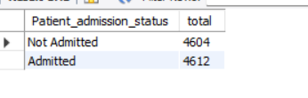
-- 2) Admission rate;

SELECT
ROUND(
SUM(CASE WHEN Patient_admission_status='Admitted' THEN 1 ELSE 0 END)*100/COUNT(*),2
) AS admission_rate
FROM hospital_emergency_room;

Patient Visit Trend
-- 1) Daily patient visit

SELECT Patient_admission_date,
COUNT(*) AS patients
FROM hospital_emergency_room
GROUP BY Patient_admission_date
ORDER BY Patient_admission_date;
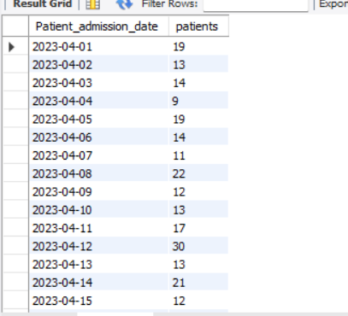 (Consist 2 year data)

-- 2)Monthly Patient visit

SELECT
MONTHNAME(Patient_admission_date) AS month,
COUNT(*) AS patients
FROM hospital_emergency_room
GROUP BY MONTH(Patient_admission_date),MONTHNAME(Patient_admission_date)
ORDER BY MONTH(Patient_admission_date);
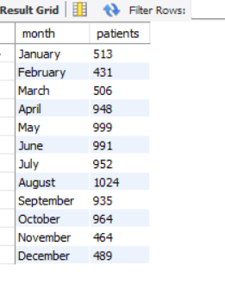
-- 3) Day wise visit

SELECT
DAYNAME(Patient_admission_date) AS day_name,
COUNT(*) AS patients
FROM hospital_emergency_room
GROUP BY DAYNAME(Patient_admission_date);
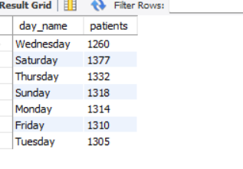
TIME ANALYSIS
-- 1)Patients by Hour:
SELECT
HOUR(Patient_admission_time) AS hour,
COUNT(*) AS patients
FROM hospital_emergency_room
GROUP BY HOUR(Patient_admission_time)
ORDER BY hour;
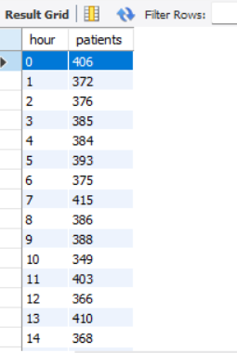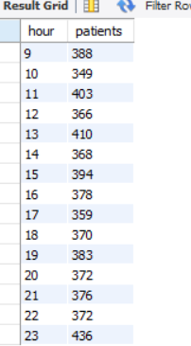
-- 1)Busiest Hour:

SELECT
HOUR(Patient_admission_time) AS hour,
COUNT(*) AS patients
FROM hospital_emergency_room
GROUP BY hour
ORDER BY patients DESC
LIMIT 1;
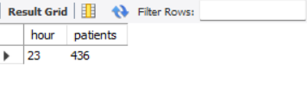
Wait Time Analysis
-- 1) Average waiting time

SELECT
ROUND(AVG(Patient_waittime),2) AS average_wait
FROM hospital_emergency_room;
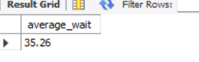
-- 2) Maximum waiting time

SELECT
MAX(Patient_waittime) AS max_wait
FROM hospital_emergency_room;
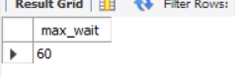
-- 3) Patient seen within 30 minutes

SELECT
COUNT(*) AS patients_seen_within_30
FROM hospital_emergency_room
WHERE Patient_waittime<=30;
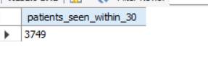
-- 4) Percentage of Patient seen within 30 minutes

SELECT
ROUND(
SUM(CASE WHEN Patient_waittime<=30 THEN 1 ELSE 0 END)*100/COUNT(*),2
) AS percentage
FROM hospital_emergency_room;
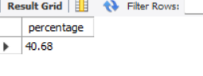

Department Referral Analysis
-- 1) Patients by Department:

SELECT
department_referral,
COUNT(*) AS total_patients
FROM hospital_emergency_room
GROUP BY department_referral
ORDER BY total_patients DESC;
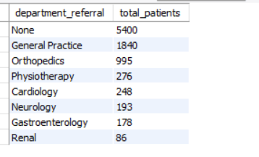
-- 2) Top 5 Departments:

SELECT
department_referral,
COUNT(*) AS total_patients
FROM hospital_emergency_room
GROUP BY department_referral
ORDER BY total_patients DESC
LIMIT 5;
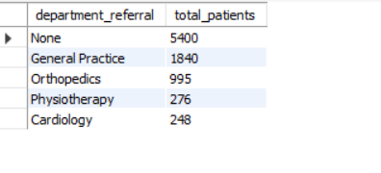

Satisfaction Analysis

-- 1) Average Satisfaction Score;

SELECT
ROUND(AVG(patient_satisfaction_score),2)
FROM hospital_emergency_room;

-- 2) Satisfaction by Department;

SELECT
department_referral,
ROUND(AVG(patient_satisfaction_score),2) AS avg_score
FROM hospital_emergency_room
GROUP BY department_referral
ORDER BY avg_score DESC;
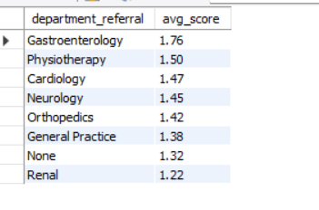
DEMOGRAPHIC ANALYSIS

-- 1) Patients by Race:

SELECT patient_race,
COUNT(*) AS total
FROM hospital_emergency_room
GROUP BY patient_race;
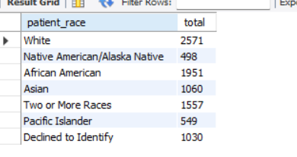
-- 2) Patients by Gender and Age Group:

SELECT patient_gender, patient_age_group,
COUNT(*) AS total
FROM hospital_emergency_room
GROUP BY patient_gender,patient_age_group;
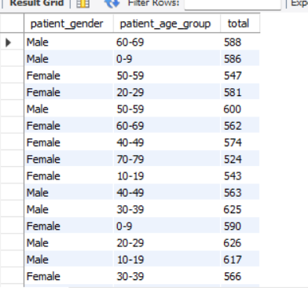
PEAK DAYS
-- 1) Top 10 busiest days:

SELECT patient_admission_date,
COUNT(*) AS patient
FROM hospital_emergency_room
GROUP BY patient_admission_date
ORDER BY patient DESC
LIMIT 10
;
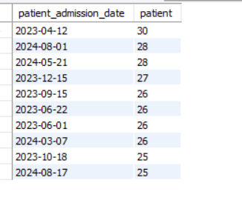
-- Rank Departments by Patient Count:

SELECT department_referral,
COUNT(*) AS patient,
RANK() OVER(ORDER BY COUNT(*) DESC) AS ranking
FROM hospital_emergency_room
GROUP BY department_referral;
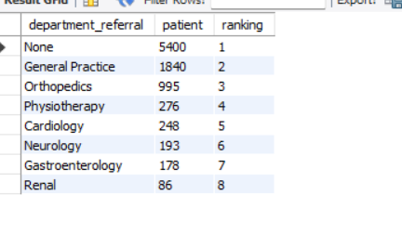
-- Average count of daily patient;
SELECT
ROUND(AVG(daily_patients), 2) AS average_daily_patient_count
FROM (
SELECT
patient_admission_date,
COUNT(*) AS daily_patients
FROM hospital_emergency_room
GROUP BY patient_admission_date
) AS daily_count;
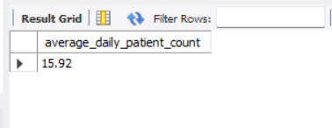

-- Patient for each day:

SELECT
patient_admission_date,
COUNT(*) AS daily_patient_count
FROM hospital_emergency_room
GROUP BY patient_admission_date
ORDER BY daily_patient_count DESC
LIMIT 10;
